Belinda Hill  First Assistant  Immediate Release  Harris County District Attorney  Devon Anderson  July 1st, 2014 | 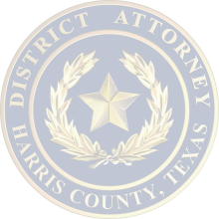 | Criminal Justice Center  1201 Franklin, Suite 600  Houston, Texas 77002  Contact  Camille Hepola  Jeff McShan  (713) 755-0122

Media Advisory

Who: Devon Anderson, Harris County District Attorney
Annise Parker, Houston Mayor
Charles McClelland, Houston Police Chief
Adrian Garcia, Harris County Sheriff
Sarah Schimmer, AAA Texas

What: Announcement of No Refusal Initiative after two DWI related traffic fatalities in the last two weeks

Where: Sam Houston Park
1000 Bagby (at the corner of Allen Parkway and Bagby)
Houston, Tx

There will be media parking available along Allen Parkway and there will be parking available at the Heritage Society 300 Allen Parkway.

When: Wednesday July 2nd, 2014 at 10:00AM

Contact: Camille Hepola 713-898-7823

